SQL> CREATE TABLE CLASSROOM(
2 BUILDING VARCHAR(15),
3 ROOM_NUMBER VARCHAR(7),
4 CAPACITY NUMERIC(4,0),
5 PRIMARY KEY (BUILDING, ROOM_NUMBER));

Table created.
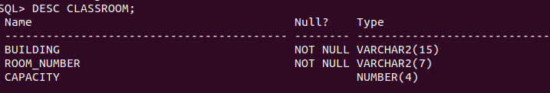
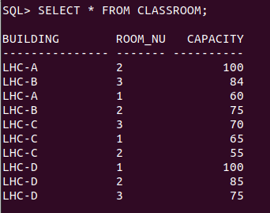

SQL> CREATE TABLE DEPARTMENT(
2 DEPT_NAME VARCHAR(20),
3 BUILDING VARCHAR(15),
4 BUDGET NUMERIC(12,2) CHECK(BUDGET>0),
5 PRIMARY KEY(DEPT_NAME));

Table created.
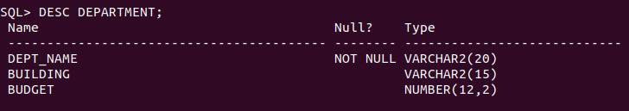

SQL> CREATE TABLE COURSE(
2 COURSE_ID VARCHAR(8),
3 TITLE VARCHAR(50),
4 DEPT_NAME VARCHAR(20),
5 CREDITS NUMERIC(2,0) CHECK(CREDITS>0),
6 PRIMARY KEY(COURSE_ID),
7 FOREIGN KEY(DEPT_NAME) REFERENCES DEPARTMENT ON DELETE SET NULL);

Table created.
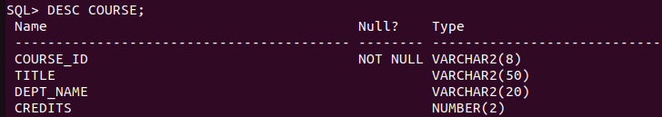

SQL> CREATE TABLE INSTRUCTOR(
2 ID VARCHAR(5),
3 NAME VARCHAR(20) NOT NULL,
4 DEPT_NAME VARCHAR(20),
5 SALARY NUMERIC(8,2) CHECK (SALARY>29000),
6 PRIMARY KEY(ID),
7 FOREIGN KEY(DEPT_NAME) REFERENCES DEPARTMENT ON DELETE SET NULL);

Table created.
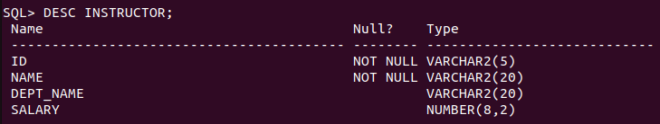

SQL> CREATE TABLE SECTION(
2 COURSE_ID VARCHAR(8),
3 SEC_ID VARCHAR(8),
4 SEMESTER VARCHAR(6) CHECK(SEMESTER IN ('FALL','WINTER','SPRING','SUMMER')),
5 YEAR NUMERIC(4,0) CHECK(YEAR > 1701 AND YEAR < 2100),
6 BUILDING VARCHAR(15),
7 ROOM_NUMBER VARCHAR(7),
8 TIME_SLOT_ID VARCHAR(4),
9 PRIMARY KEY(COURSE_ID, SEC_ID, SEMESTER, YEAR),
10 FOREIGN KEY(COURSE_ID) REFERENCES COURSE ON DELETE CASCADE,
11 FOREIGN KEY(BUILDING, ROOM_NUMBER) REFERENCES CLASSROOM ON DELETE SET NULL);

Table created.
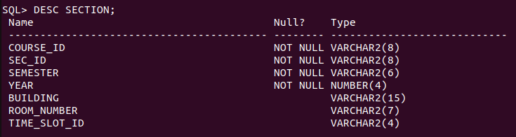

SQL> CREATE TABLE TEACHES(
2 ID VARCHAR(5),
3 COURSE_ID VARCHAR(8),
4 SEC_ID VARCHAR(8),
5 SEMESTER VARCHAR(6),
6 YEAR NUMERIC(4,0),
7 PRIMARY KEY (ID, COURSE_ID, SEC_ID, SEMESTER, YEAR),
8 FOREIGN KEY(COURSE_ID, SEC_ID, SEMESTER, YEAR) REFERENCES SECTION ON DELETE CASCADE,
9 FOREIGN KEY(ID) REFERENCES INSTRUCTOR ON DELETE CASCADE);

Table created.
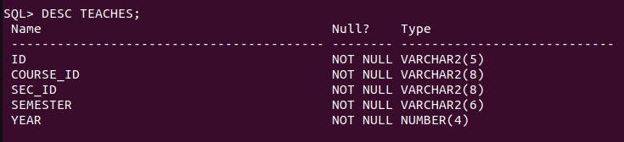

SQL> CREATE TABLE STUDENT(
2 ID VARCHAR(5),
3 NAME VARCHAR(20) NOT NULL,
4 DEPT_NAME VARCHAR(20),
5 TOT_CRED NUMERIC(3,0) CHECK(TOT_CRED>=0),
6 PRIMARY KEY(ID),
7 FOREIGN KEY(DEPT_NAME) REFERENCES DEPARTMENT ON DELETE SET NULL);

Table created.
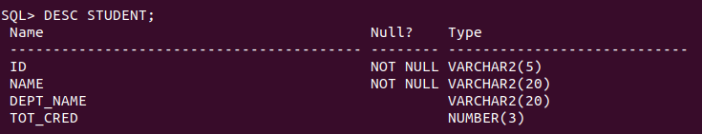

SQL> CREATE TABLE TAKES(
2 ID VARCHAR(5),
3 COURSE_ID VARCHAR(8),
4 SEC_ID VARCHAR(8),
5 SEMESTER VARCHAR(6),
6 YEAR NUMERIC(4,0),
7 GRADE VARCHAR(2),
8 PRIMARY KEY(ID, COURSE_ID, SEC_ID, SEMESTER, YEAR),
9 FOREIGN KEY(COURSE_ID, SEC_ID, SEMESTER, YEAR) REFERENCES SECTION ON DELETE CASCADE,
10 FOREIGN KEY(ID) REFERENCES STUDENT ON DELETE CASCADE);

Table created.
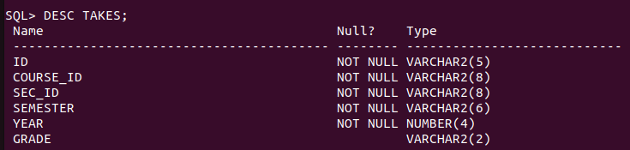

SQL> CREATE TABLE ADVISOR(
2 S_ID VARCHAR(5),
3 I_ID VARCHAR(5),
4 PRIMARY KEY (S_ID),
5 FOREIGN KEY (I_ID) REFERENCES INSTRUCTOR(ID) ON DELETE SET NULL,
6 FOREIGN KEY(S_ID) REFERENCES STUDENT(ID) ON DELETE CASCADE);

Table created.
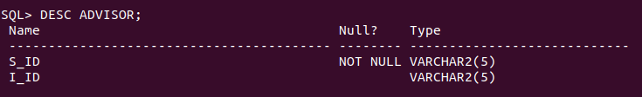

SQL> CREATE TABLE TIME_SLOT(
2 TIME_SLOT_ID VARCHAR(4),
3 DAY VARCHAR(4),
4 START_HR NUMERIC(2) CHECK(START_HR>=0 AND START_HR<24),
5 START_MIN NUMERIC(2) CHECK(START_MIN>=0 AND START_MIN<60),
6 END_HR NUMERIC(2) CHECK(END_HR>=0 AND END_HR<24),
7 END_MIN NUMERIC(2) CHECK(END_MIN>=0 AND END_MIN<60),
8 PRIMARY KEY(TIME_SLOT_ID, DAY, START_HR, START_MIN));

Table created.
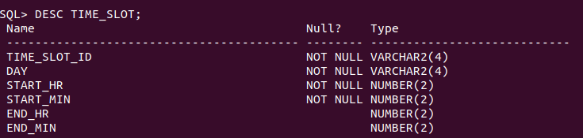

SQL> CREATE TABLE PREREQ(
2 COURSE_ID VARCHAR(8),
3 PREREQ_ID VARCHAR(8),
4 PRIMARY KEY(COURSE_ID, PREREQ_ID),
5 FOREIGN KEY(COURSE_ID) REFERENCES COURSE ON DELETE CASCADE,
6 FOREIGN KEY(PREREQ_ID) REFERENCES COURSE);

Table created.




